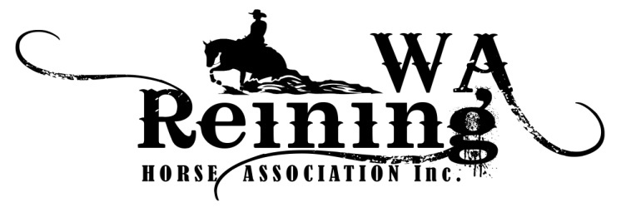

Nomination for End of Year High Point Buckle 2020

Full Name Rider/Owner

Name of Parent/Guardian if rider under 18
Address
 | State Post code
Phone | Email
Horse Name
Horse Registration #  RA/NRHA | Horse Date of Birth  (required for aged events)
Rider Registration #  WARHA/RA/NRHA | Rider Date of Birth  (required for prime time &youth)
Open $20 |  | Youth $10
Non Pro * $20 |  | Green Reiner L1/L2 $10
Prime Time * $20 |  | Rookie Pro $20

Limited Non Pro* $20 |  | Rookie 1 & 2 $20
Novice Horse NP 1 $20 |  | Novice Horse Open 1 $20
Novice Horse NP 2 $20 |  | Novice Horse Open 2 $20

Account Name: Western Australian Reining Horse Association BSB 036-122 Account 566314
Please email Nomination Forms to: Liz@slidersdrift.horse
Alternatively posted to Liz Galliott - PO Box 306, Muchea, WA 6501
Signature Dated

…………………………………………………………...........................................................................................

The WARHA 2020 High Point Awards will be run as per the calendar year.
All points will be accumulated in shows run by recognised reining clubs in Western Australia.
All nominees must be financial members of WARHA.
All classes will have points allocated as 1st - 3, 2nd - 2, 3rd - 1, regardless of the number of entries.
A zero score will not receive points.
Tallies will only start once nomination forms and monies are received by WARHA, and will only be accepted until 30th June 2020.
Concurrent Classes: Nominees who enter concurrent classes will accumulate only one set of points as per place against all nominees' scores in that set of classes.
All Conditions of Entry for nominated classes must be met for each show/club.

Any further queries can be emailed to

WARHACommittee@outlook.com

